Physics Name_______________________________ Date ___________ Block _______

4 - Transverse Pulse Lab on PheT “Waves on a String”

Question – How does a fixed end or loose end affect a transverse pulse as it is reflected back on its axis?

Introduction – This lab will test the loose end and fixed end of a transverse pulse. Open the PheT site to Waves on a String using the link below. There are two different transverse pulse activities with this lab. The first activity uses a fixed and the second uses a loose end for the pulse. Use the given settings for each pulse wave. You can stop the pulse to draw or use the small arrows to step the video.

Open Up PheT “Waves on a String” using the link below.
https://phet.colorado.edu/en/simulation/wave-on-a-string

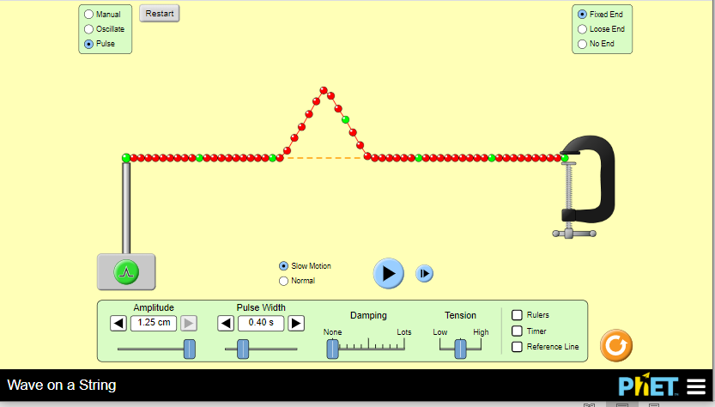
Part B Transverse Pulse Lab – Fixed End

Please use the following settings:
- Pulse
- Amplitude at 1.25
- Pulse Width at .40
- Damping at None
- Tension at Med.
- Use slow motion
- Left Fixed End
- Right Fixed End.

1. Draw a fixed end on the left and fixed end on the right of the axis. Draw the pulse as it moves to the right with arrow for direction.

2. Draw a fixed end on the left and fixed end on the right part of the axis. Draw the pulse after it hits the right end and is reflected back on the axis. Include an arrow for direction.

3. Did the pulse stay on top of the axis or move below the axis as the pulse was reflected back?

4. Did the speed of the pulse increase, decrease, or stay the same as the pulse was reflected back?

5. Did the amplitude of the pulse increase, decrease, or stay the same as the pulse was reflected back?

6. Did the pulse width increase, decrease, or stay the same as the pulse was reflected back?

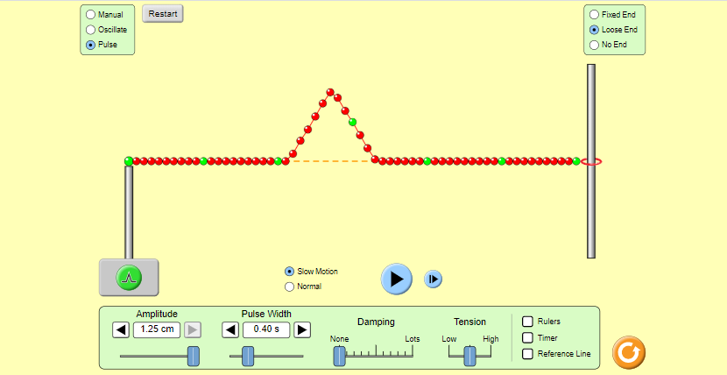
Part B Transverse Pulse Lab – Loose End

Please use the following settings:
- Pulse
- Amplitude at 1.25
- Pulse Width at .40
- Damping at None
- Tension at Medium
- Use slow motion
- Fixed Left End
- Right Loose End.

7. Draw a fixed end on the left and loose end on the right. Draw the pulse as it moves to the right with arrow for direction.

8. Draw the fixed end on the left and loose end on the right. Now draw the pulse after it reaches the loose right end and is reflected back. Include and arrow for direction.

9. Did the pulse stay on top of the axis or move below the axis as the pulse was reflected back?

10. Did the speed of the pulse increase, decrease, or stay the same as the pulse was reflected back?

11. Did the amplitude of the pulse increase, decrease, or stay the same as the pulse was reflected back?

12. Did the pulse width increase, decrease, or stay the same as the pulse was reflected back?

Part B Transverse Pulse Lab – Your Own Design
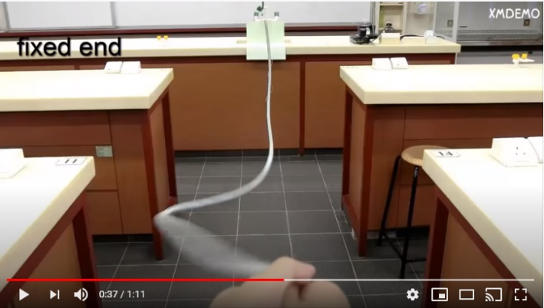
Transverse Pulse Fixed end vs Loose end
https://youtu.be/1PsGZq5sLrw

13. Now, explore the “Waves on a String” fixed end or loose end and create your own interesting pulse wave. Please past your Pulse wave in the space below. What settings did you use to create this wave? Why did you decide to use the fixed or loose end? What was really interesting or surprising about the pulse wave you created? Please write your summary paragraph in the space below.

Stop your pulse wave and take a snip. Paste your loose end or fixed end pulse wave pic in the space below:

Write your reflection paragraph in the space below:

