Name: ______________________________________ Date: ________________________

Student Exploration: Food Chain

Vocabulary: consumer, ecosystem, energy pyramid, equilibrium, food chain, population, predator, prey, producer

Prior Knowledge Questions (Do these BEFORE using the Gizmo.)
The Food Chain Gizmo shows a food chain with hawks, snakes, rabbits, and grass. In this simulation, the hawks eat snakes, the snakes eat rabbits, and the rabbits eat grass.

- Producers are organisms that do not need to eat other organisms to obtain energy.
  - Which organism is a producer in this food chain? ____________________________
  - Where does the producer get its energy? __________________________________

- Consumers must eat other organisms for energy. Which organisms are consumers in this food chain? _______________________________________________________________
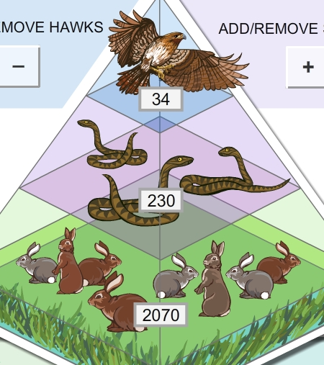

Gizmo Warm-up
The SIMULATION pane of the Gizmo shows the current population, or number, of each organism in the food chain.

- What are the current populations of each organism?

Hawks: _____ Snakes: _____ Rabbits: _____ Grass: _____

- Select the BAR CHART tab, and click Play (). What do you notice about each population as time goes by?

_________________________________________________________________________

If populations don’t change very much over time, the ecosystem is in equilibrium.

- Notice the populations decrease as you go from the bottom of the food chain to the top. Why do you think this is so? ______________________________________________________
_________________________________________________________________________

This diagram, showing decreasing populations at each level, is called an energy pyramid.

Activity A:  Predator-prey relationships | Get the Gizmo ready:  - Click Reset ().  - Check that the BAR CHART tab is selected. | 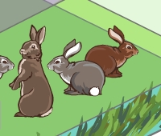

Question: Predators are animals that hunt other animals, called prey. How do predator and prey populations affect one another?

- Observe: Run the Gizmo with several different starting conditions. You can use the + or – buttons to add or remove organisms, or you can choose Diseased from the dropdown lists.

- Form hypothesis: How do you think predator and prey populations affect one another?

_________________________________________________________________________

_________________________________________________________________________

- Predict: Based on your hypothesis, predict how changing the rabbit population will affect the other organisms at first. Write “Increase” or “Decrease” next to each “Prediction” in the table.

Change | Grass | Snakes | Hawks
Doubling rabbit population | Prediction: | Prediction: | Prediction:
 | Result: | Result: | Result:
Halving rabbit population | Prediction: | Prediction: | Prediction:
 | Result: | Result: | Result:

- Test: Add rabbits until the population is about twice as large as it was (200% of balance). Click Play, and then Pause () after approximately ONE month. Next to each “Result” line in the table, write “Increase” or “Decrease.” Click Reset and then halve the rabbit population (50% of balance). Record the results for this experiment in the table as well.

    - How did doubling the rabbit population affect the grass, snakes, and hawks at first?

___________________________________________________________________

___________________________________________________________________

    - How did halving the rabbit population affect the grass, snakes, and hawks at first?
___________________________________________________________________

___________________________________________________________________

(Activity A continued on next page)
Activity A (continued from previous page)

- Predict: Predict how changing the snake and hawk populations will affect the other organisms within the first month. In the tables below, write your predictions.

Change | Grass | Rabbits | Hawks
Doubling snake population | Prediction: | Prediction: | Prediction:
 | Result: | Result: | Result:
Halving snake population | Prediction: | Prediction: | Prediction:
 | Result: | Result: | Result:

Change | Grass | Rabbits | Snakes
Doubling hawk population | Prediction: | Prediction: | Prediction:
 | Result: | Result: | Result:
Halving hawk population | Prediction: | Prediction: | Prediction:
 | Result: | Result: | Result:

- Test: Click Reset. Try each experiment with the Gizmo. Record each result after one month.

    - How did increasing the snakes affect the grass? ____________________________
Explain why: ________________________________________________________

___________________________________________________________________

    - How did increasing the hawks affect the rabbits? ____________________________

Explain why: ________________________________________________________

___________________________________________________________________

- Draw conclusions: In general, what effect did removing prey have on predators? _________

_________________________________________________________________________

What effect did removing predators have on prey? _________________________________

_________________________________________________________________________

Extend your thinking: In North America, many top predators, such as wolves, have been driven nearly to extinction. What effect do you think this has on their main prey, deer? Write your answer on a separate sheet, and/or discuss with your classmates and teacher.

Activity B:  Long-term changes | Get the Gizmo ready:  - Click Reset.  - Select the GRAPH tab. | 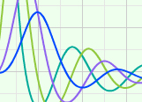

Question: An ecosystem is a group of living things and their physical environment. How do ecosystems react to major disturbances?

- Observe: Kill off most of the hawks using the – button, and then click Play. Observe the GRAPH for about 12 months, and then click Pause. What happens?

_________________________________________________________________________

_________________________________________________________________________

- Analyze: Explain why you think the population of each organism changed the way it did. (Use extra paper if necessary.)

_________________________________________________________________________

_________________________________________________________________________

_________________________________________________________________________

- Experiment: Click Reset. Try making other changes to the ecosystem. Use the + or – buttons, or choose Diseased from the dropdown lists. Click Play and observe for at least 12 months. Record what happens on another sheet of paper or in your notes.

- Summarize: Give at least one example of each of the following:

    - A major disturbance that the ecosystem was able to recover completely from.

___________________________________________________________________

    - A major disturbance that caused the ecosystem to stabilize at a new equilibrium.

___________________________________________________________________

    - A major disturbance that caused the ecosystem to completely collapse.

___________________________________________________________________

    - (Challenge) A major disturbance that almost caused a total collapse, but that the ecosystem was able to recover from eventually.

___________________________________________________________________

