Conservation of Momentum Lab

Can you find the Pattern?

Purpose: Compare momentum before and after a collision in ELASTIC and INELASTIC Collisions
------------------------------------------------------------------------------------------------------------------------------------------------------------------------------------

Calculate Momentum Before AND Momentum After---Directions: Set up simulation as picture indicates, run it, then calculate momentum of EACH object BEFORE and AFTER the collision—Show all work and units! Remember momentum is mass X velocity.

Car Set-up--ELASTIC | Momentum Before  Red | Momentum Before  Blue | Momentum After  Red | Momentum After  Blue
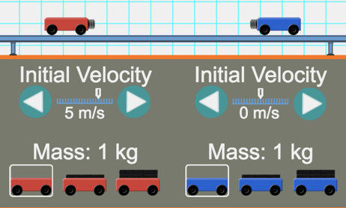
Car Set-up--ELASTIC | Momentum Before  Red | Momentum Before  Blue | Momentum After  Red | Momentum After  Blue
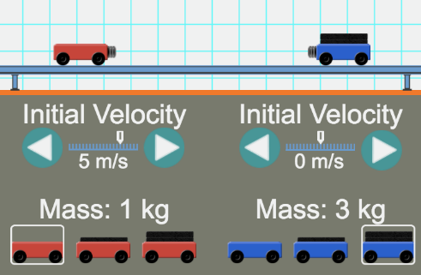
Car Set-up--ELASTIC | Momentum Before  Red | Momentum Before  Blue | Momentum After  Red | Momentum After  Blue
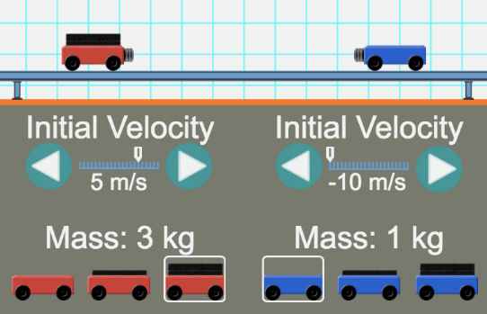

Can you find the Pattern?--What pattern do you notice comparing the momentum BEFORE to the momentum AFTER in an elastic collisions?

------------------------------------------------------------------------------------------------------------------------------------------------------------------------------------
NOW TRY AN INELASTIC COLLISION

Car Set-up--INELASTIC | Momentum Before  Red | Momentum Before  Blue | Momentum of the ENTIRE object  (once they have stuck together)
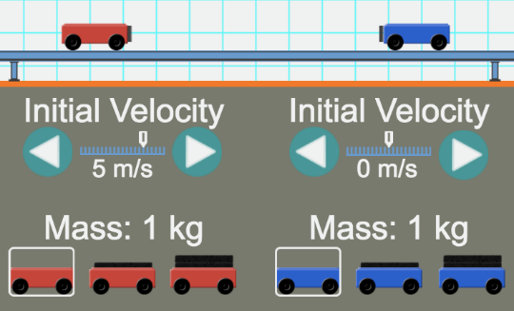
Car Set-up--INELASTIC | Momentum Before  Red | Momentum Before  Blue | Momentum of the ENTIRE object  (once they have stuck together)
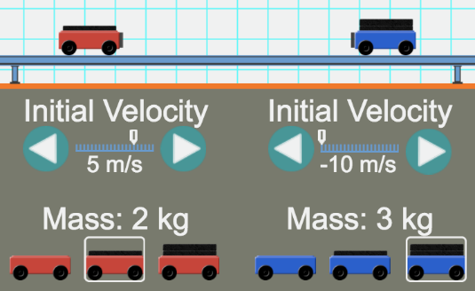

Can you find the Pattern?--What pattern do you notice comparing the momentum BEFORE to the momentum AFTER in an elastic collisions?

------------------------------------------------------------------------------------------------------------------------------------------------------------------------------------
Application of the Law of Conservation of Momentum
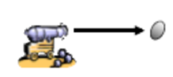
- A 7 kg cannon ball is fired from a cannon with an exit velocity of 30 m/s. Explain what has to happen to the cannon as the cannonball is being fired using what you have learned about the Law of Conservation of Momentum.

