Finding a Balance is an environmental study project that allows you to consider real environmental dilemmas concerning overpopulation in the city of Columbia and to provide solutions to these dilemmas. The student packet gives you most of the information you’ll need to answer the Focus Question, information like maps, data, background, a reading about the region, and a description of the “Interested Parties,” or the various interest groups that have a stake in the outcome of the Focus Question. At the end of the reading, your group will be asked to present and justify a solution to the environmental dilemma below.

Reading:
Columbia Public Schools will evaluate property in south Columbia, which is planned for a new middle school, before closing on the land’s sale.
The Columbia Board of Education recently approved a $2.9 million land purchase agreement for 63 acres of Sinclair Farm, which is owned by the University of Missouri. Sinclair Farm is on Sinclair Road south of Nifong Boulevard and previously was used for research.
Between 1972 and 1981, liquid radioactive waste from MU research was placed into a pit and burned on a 2-acre plot of the more than 500-acre Sinclair Farm. The Nuclear Regulatory Commission has since tested the land and determined it safe to use and sell.
CPS Superintendent Peter Stiepleman said Board of Curators approved the contract and the Board of Education approved a two-phase evaluation plan for the property Thursday.
“Our first job, before anything else, is to keep children safe,” Stiepleman said in an email. “The NRC was asked to evaluate the entire 500+ acre farm to determine if there were any concerns that would preclude the University to sell ... and as other community members who live near the property have pointed out, the land was determined to be safe.”
He said the district is approaching the property just like a prospective homeowner would approach a home. That means inspecting the property with a third party to confirm what the university and NRC have found in prior evaluations of the property: that it is safe to purchase.
Christian Basi, UM spokesman, said this is the first section of the property to be sold. The money made from the land sale will benefit the nursing school.
The district plans to use the property to open a new middle school by 2020. The school is needed to relieve overcrowding at Gentry Middle School. Stiepleman said the district has six middle schools and five of them are on Worley or above. Most of the school district, he said, recognizes the need to respond to growth in southwest Columbia.
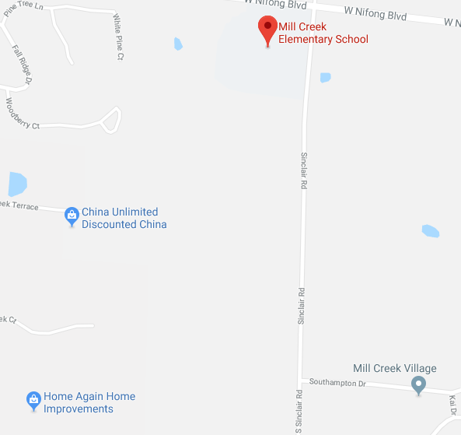
“The greatest growth is projected to be in the southwest - a projection of more than 30 percent over the next 10 years alone,” Stiepleman said in an email.

Proposed site of new middle school

Stiepleman said the Columbia Board of Education chose the property after what he called an extensive search. The district initially considered more than 20 possible sites. He said the Sinclair Farm property was most desirable for many reasons and specifically mentioned the access the infrastructure being a positive.
Columbia Daily Tribune, June 26, 2017
Focus Question: How will your group develop the rest of the area around the middle school? Keep in mind all viewpoints. Create an action plan to keep all interested parties satisfied as the new middle school is being built.
The Interested Parties
Here is an overview of the competing interests that affect the new middle school region. As your group works to answer the Focus Question, each person will take a role as an environmentalist, business owner, or parent/student.
ENVIRONMENTALISTS
Environmentalists want to stop the destruction of the prairies, an ecosystem which is in jeopardy in mid Missouri. The once vast prairies of Missouri have diminished from 15 million acres to a few hundred acres by the 1970s.
COLUMBIA BUSINESS LEADERS
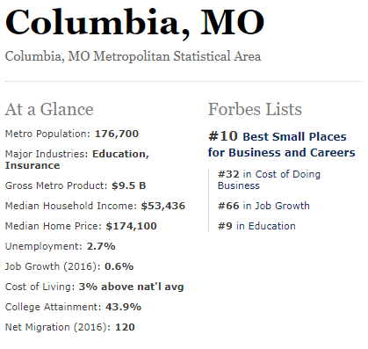
Columbia ranks #10 in the nation for small business growth and has unemployment rate of 2.7%. Columbia business leaders want to continue fostering this business mind set by having space available for business real estate.
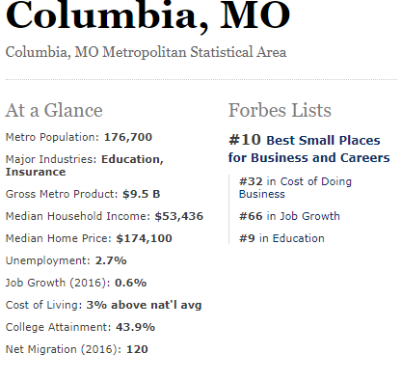
PARENT/STUDENT
A few parents and students will see their lives affected by the new middle school - either their child, themselves, or their friends will be going to the new middle school. All parents of the CPS school district pay property tax that goes towards the school district. Is it fair that all residents of the CPS district pay the same rate when the amenities in each school building differ widely? Property is taxed at 19% of its value which is quite a lot when some students go to brand new schools with state of the art facilities and some students go to old schools with trailers.
The New Middle School - What You Need to Know
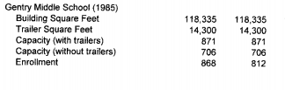
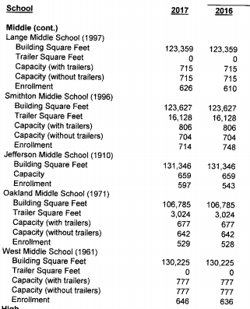
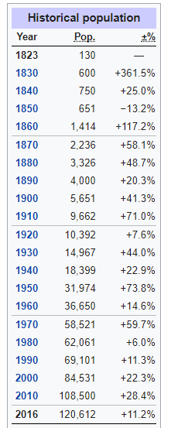
Columbia’s population has increased dramatically since its early beginnings in the 1800s. It is currently one of the fastest growing metropolitan areas in the Midwest. Most of the population push and new development has been towards the southwest corner of town. The area south of Nifong where Gentry Middle School, Mill Creek Elementary, and Beulah Ralph Elementary School are currently was once wilderness. In addition to new schools being built, there has also been an influx in student housing on the southside of town as well. All of this new population needs place to eat and shop driving up the amount of restaurants and shops on the southside of town as well.
The new middle school plans on opening in 2020 and will help alleviate the overcrowding at Gentry Middle School.

Columbia Public Schools - What You Need to Know
60% of the revenue for CPS comes from property tax and property owners in the city of Columbia and parts of Boone County. 54% of the CPS revenue goes towards direct instruction of student - teachers, classroom supplies, classroom resources, etc. CPS expects to pay for the new middle school through a bond (non tax increase) to keep the cost to taxpayers and the City of Columbia relatively cheap. The state of Missouri has a very complex way of funding and allocating the money of school districts so a simple redistribution of money to balance out school resources and eliminate the trailers at Gentry Middle School is not allowed. There is also the fact that no matter how much money you redistribute towards Gentry Middle School, it is still the only middle school in the district at or above capacity. Additionally, while there have been new elementary schools and a new high school built in the past five years to help with the new population boom of Columbia, there has not been a new middle school built since 1997 - Lange Middle School - on the northside of town.
The New Middle School Land - What You Need to Know
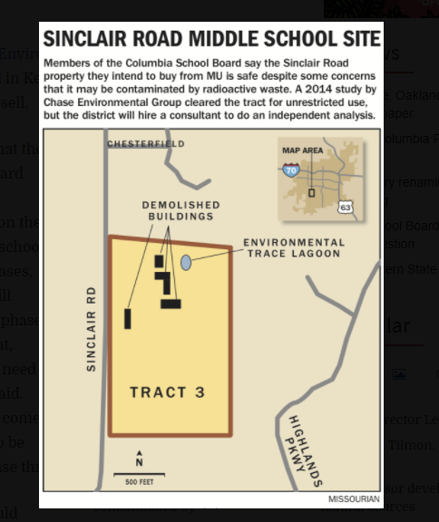
The site of the new middle school will be where the Sinclair Farm used to be. It was bought by CPS from Mizzou for $2.9 million. The site was originally used for radioactive materials research, incineration, land disposal and radioactive materials storage at the university. Over time, the site has been reclaimed by prairie and wildlife land. The Chase Environmental Group has analyzed the property and concluded that there is no contamination of radioactive material on the parcel CPS bought. The radioactive waste was dumped on the opposite side of the road that the middle school would be built on. Environmental concerns about the radioactive waste site have still been brought up even though tests and analysis have shown that the location of the new middle school is safe and contamination free.
Since 1981 when the research farm stopped burying radioactive material, the site has been taken over by wildlife including natural prairie grasses, trees, and wildflowers. Additionally, native species of birds, insects, and small creatures have taken over part of the area as well. Building this new middle school will displace part of their homes and habitats. The photographs below shows how the Sinclair Farm location looks now before the new middle school is built.
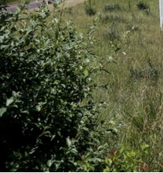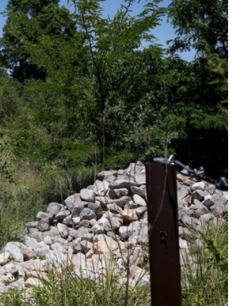
On average, each person is subjected to 310 millirems of radiation per year. This site gives off only 0.15 millirems per year.
Columbia Business Growth - What You Need to Know
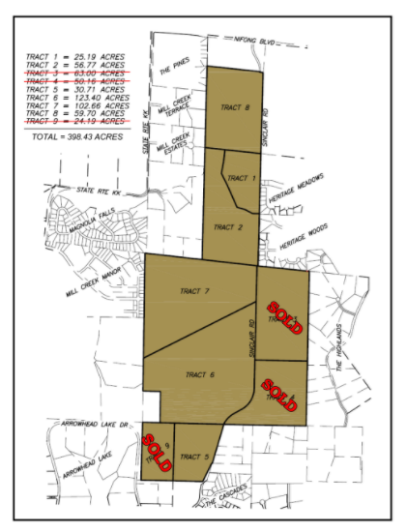
Columbia’s growth is expected to increase by 3,000 within three miles of the new middle school building. With all of this increased growth, the city of Columbia anticipates the need for new businesses including restaurants, gas stations, and shopping centers nearby. Most of the available land is within walking distance to the new middle school and quite a few neighborhoods.

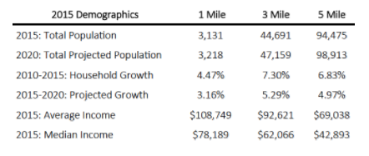
The land available is near Nifong Boulevard and Route K - two high traffic thoroughfares from the east and west sides of Columbia that will bring additional vehicular traffic to these tracts. Not only is this area of town supposed to increase in population, but the projected increase in income of the population is supposed to be very good as well.
With all of this disposable income, businesses are looking to expand into the southwest area of Columbia so shoppers do not have to travel as far to make purchases.

The Population that Lives Nearby - What You Need to Know
The people who live near the new middle school are financially very well off. Within one mile of the site households have an average income of $108,749 while within five miles of the new middle school, households have an average income of $69,038. Compared to Columbia’s average income of $33,729. Homes in the surrounding area will go for $300,000 +. There is also an upper class senior living facility nearby.
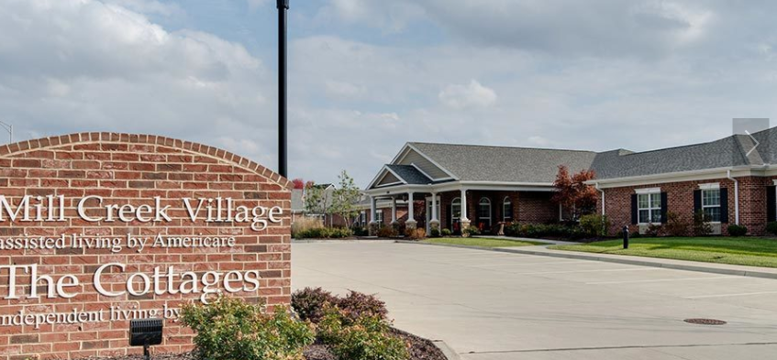
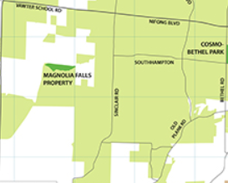
Compared to the older, more developed parts of Columbia, the southwest corner of Columbia remains underdeveloped in terms of parks, shopping, and businesses within walking distance. While there are numerous trails and parks in the central and northern portion of Columbia, there is only one park near the new middle school - Magnolia Falls Property Park. This 16 acre park is an undeveloped area of trees, fields, grassland, and a creek. Some residents of the surrounding area feel that this park could be developed to provide children a place to safely play after school and on weekends.

GLOSSARY:
Prairie - a large open area of grassland
Ecosystem - the interacting system that incorporates the living community and its nonliving physical environment
Property Tax - tax on the value of the property, part of it goes towards education
Radioactive Materials - Naturally occuring minerals that give off energy harmful to humans and living things

