March 27, 2020
http://www.loe.org/shows/shows.html?programID=20-P13-00013

Pick one of the stories; for your chosen story you will:
- Summary of story, related issues, causes and consequences
- Find additional information (include citations)
- Personal opinions, your ideas, concerns, suggestions
This should be between ½ and one full page. This should be typed.

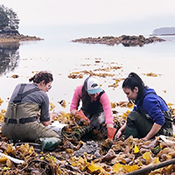
Warming Oceans And Toxic Shellfish (stream / mp3)
Many coastal native Alaskans rely on harvested shellfish as part of their subsistence lifestyle. But mussels and clams can carry a lethal dose of a toxic chemical called saxitoxin, and as ocean waters warm, the algae that produces that toxin is thriving year-round. Grist reporter Zoya Teirstein joins Host Steve Curwood to explain why the indigenous knowledge that has long protected coastal shellfishing from this threat can’t reckon with climatic changes. (10:05)
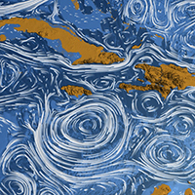

Major Ocean Currents Drifting Poleward / Jenni Doering (stream / mp3)
Ocean currents play an essential role in redistributing nutrient-rich waters and heat energy around the globe. New research from the Alfred Wegener Institute finds that global warming is pushing these vital parts of the ocean circulatory system poleward. Amy Bower, a Senior Scientist at the Woods Hole Oceanographic Institution, joins Living on Earth’s Jenni Doering to discuss the impact shifting ocean currents could have on fisheries, climate, and more. (07:06)
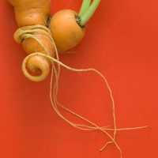

Misfit Produce at Your Doorstep / Bobby Bascomb (stream / mp3)
The new paradigm of social distancing and staying at home is whetting consumers’ appetite for grocery delivery. And several companies that will deliver straight to your doorstep aim not only for convenience but for reducing food waste as well, by sourcing produce that isn’t uniform enough for supermarket shelves, but is still perfectly edible. Living on Earth’s Bobby Bascomb talks with Abhi Ramesh, CEO of Misfits Market, about how it works. (07:26)

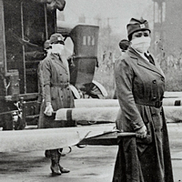
The Optimist’s Telescope: Thinking Ahead in a Reckless Age (stream / mp3)
Making decisions today based on what may be best for tomorrow or even years ahead is far from easy. The current moment is highlighting the perils of not planning ahead for challenges such as pandemics, or climate disruption. Bina Venkataraman, author of The Optimist's Telescope: Thinking Ahead in a Reckless Age, joins Host Steve Curwood to talk about how we can tackle shortsightedness in our personal lives and in society, to plan better for the future. (16:05)

