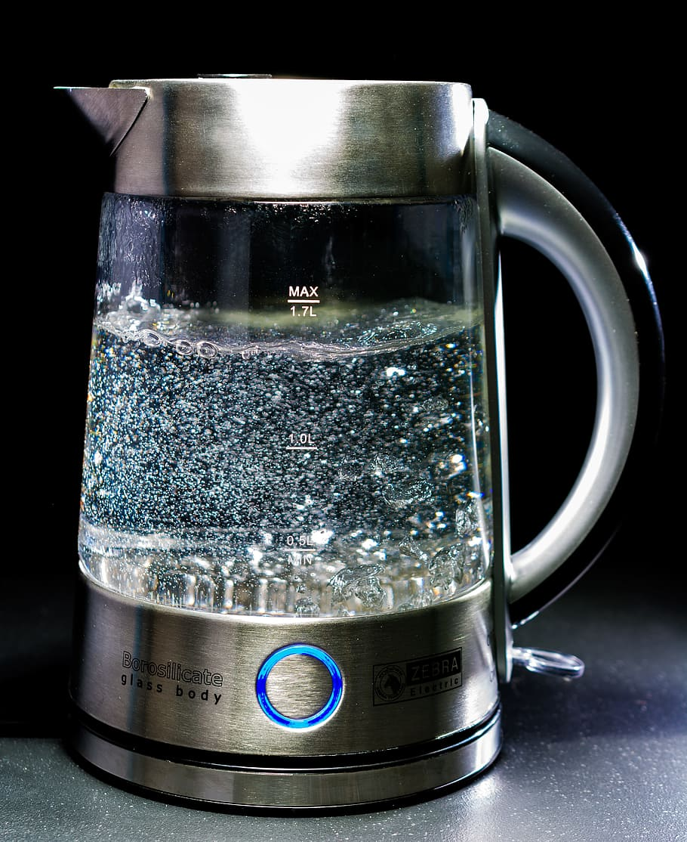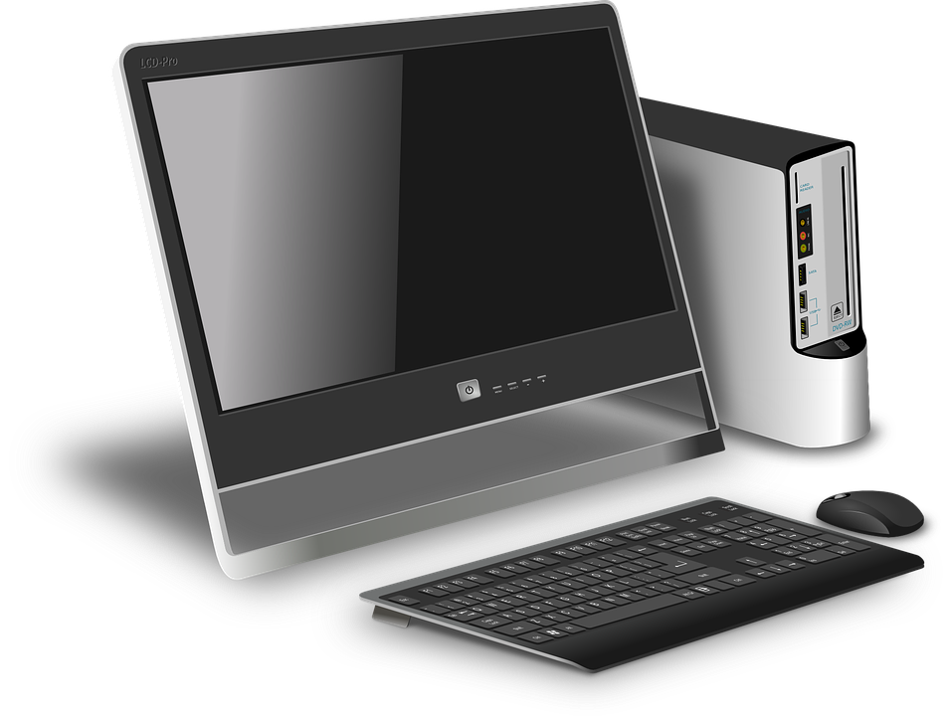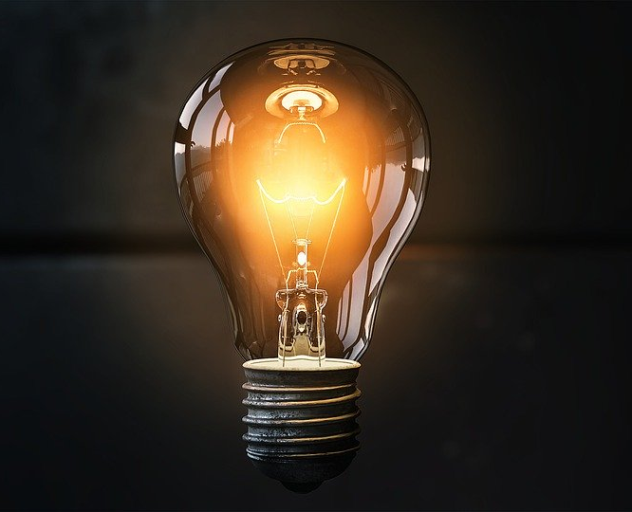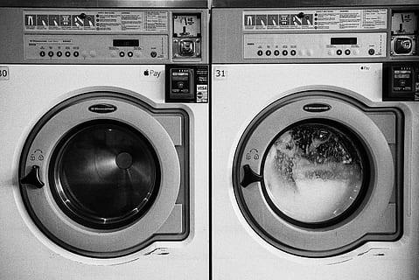

Exploring Household Energy Use
In what ways does your family use energy in your household? How could you use it more effectively and efficiently?

Introduction
- Time yourself for a minute as you write down as many things that you used today in your house that required energy from outside the house to be transferred to your house.

- Where did that energy come from? Watch these videos to learn about some of the most common ways that household energy is produced. Make note of what you’ve learned.
Water Solar Wind Coal (Thermal) Biomass

- Now let’s think about your usage of that energy, starting with what you are doing right now.
  - As you read the words on the screen, what forms of energy are represented in the computer or device?

  - Now feel different parts of your computer or device. You might notice that some parts are warm. What kind of energy is responsible for making it warm?

  - Is this type of energy that makes it warm useful for helping you do your work? Probably not, unless you are trying to get warm! Efficiency is a measure of how useful the energy still is when it changes from one form to another.
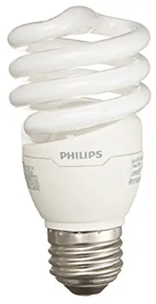

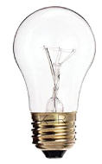
- How efficient are other energy-using devices in your home? Bring your hand near a light bulb in your house (but don’t touch it!). Does it seem warm? Try different lights in your house. You should notice that traditional (incandescent) bulbs are typically warmer that energy efficient ones (e.g. LED or Compact Fluorescent). Why do you think that is?
Explore common energy transformations

- Explore energy transformations Go to the PhET Energy Forms and Changes simulation and click on “systems”. Check the box for “energy symbols”.
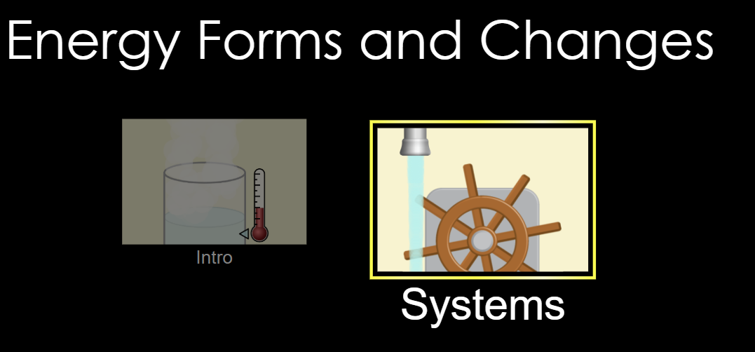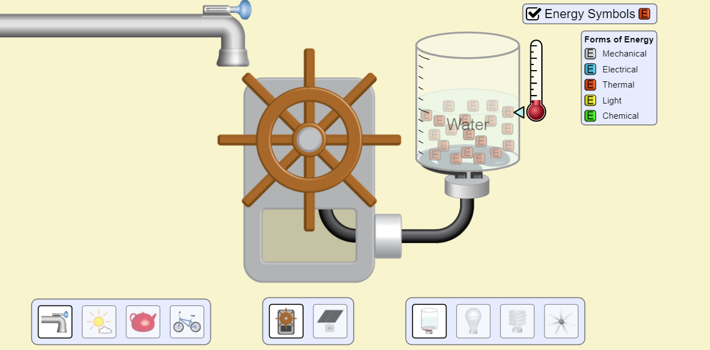

- Try changing various pieces of the system to see how you can make a water heater warm the water, or a light bulb shine. Describe your experiments and your observations:

What my system included: | What I observed:

- How do the inputs represent different energy sources from the videos (water, solar, etc)?

- Let’s focus now on efficiency.
  - In which systems is thermal energy most useful?

  - Which systems are inefficient, producing thermal energy that is NOT useful?

  - Which type of lightbulb is most efficient?

  - What else did you discover or learn?

Application (Your home)
- Consider your household use of energy. Where does your energy come from? Do some research!

- How might you reduce the amount of undesirable thermal energy output in your home?

- Share it. Think of a way to share what you’ve learned (Poster? Picture? List of changes?) and post it to social media #CPSscience and/or email your teacher.

