Adaptation Scavenger Hunt

Directions:

There are organisms with adaptations all around you! Go outside and look around. Find and take a picture of at least 10 of the following adaptations. Create a chart or poster - on paper or electronic. Include the name of adaptation, picture of organism with specific adaptation, and an explanation of the adaptation (how it benefits the organism). Submit electronically to your teacher in whatever format they ask you too.

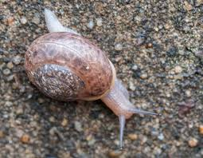
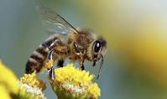
Adaptations to look for:
- Leaves
- Needles (on pine trees)
- Thorns
- Bright colors (plant or animal)
- Odor/Fragrance
- Camouflage
- Fur or feathers
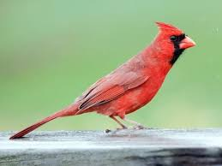
- Wings (bird or insect)
- Roots
- Ability to climb (claws or sticky feet)
- A seed adaptation (sticky, blows in the wind, etc)
- Fins or tail
- Lives underwater
- Webbed Feet
- Gills
- Stingers
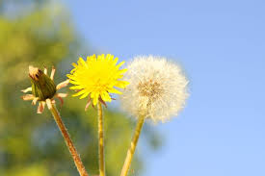
- Spikes (on trees)
- Mimicry (Copies something from another organism)
- Poison or Venom (Plant or insect)
- Vocalizes (Makes verbal noises)
- Hard Shell (animal or insect)
- Bends toward the light (tree)
- Climbs toward the light (plant or vine)
- Other adaptations (think about your pets)

