Name: Date:

Student Exploration: Embryo Development

Vocabulary: Blastula, Carnegie stages, differentiation, ectoderm, embryo, embryology, embryonic stem cells, endoderm, fetus, gastrula, inner cell mass, mesoderm, morula, neurula, primitive streak, trilaminar disk, zygote

Prior Knowledge Questions (Do these BEFORE using the Gizmo.)

- The images below show embryos of different species at different stages of development. Label the images below with 1-4 from least developed to most developed.
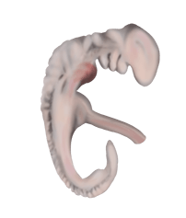
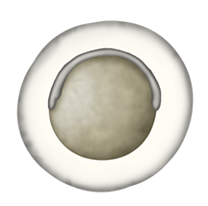
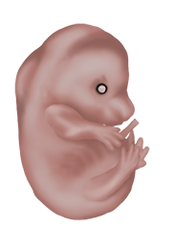

A B C D

- Which image above do you think is a human? Explain.

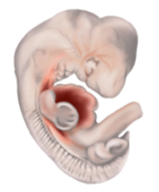

Gizmo Warm-up
Embryology is the study of the development of embryos from a single cell to a multicellular fetus. In the Embryo Development Gizmo, you will compare the development of different animals and learn the details of mammalian development. To begin, be sure the COMPARE tab is selected.

- What do the images have in common?

Click on the check box to turn on Scale bars and labels. You are observing the zygotes, or fertilized single cells, of five animals.

- At this point, are you able to tell which animal is which? Explain.

Activity A:  Comparative embryology | Get the Gizmo ready:  - Make sure the COMPARE tab is selected and the Developmental stage slider is on stage 1.  - Turn off Scale bars and labels. | 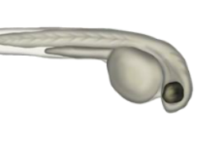

Introduction: Comparative embryology compares embryos of different species to gain insight into how they are related. To provide a framework for this comparison, embryologists divide this process into 23 Carnegie stages. You will look at seven of these stages in this activity.

Question: Can we use comparative embryology to determine the relatedness of species?

- Challenge: Drag the labels to the embryos you think they belong to. Fill in the first row of the table below with your guesses. Then, move the Developmental stage slider one position to the right, to Carnegie stage 4. Rearrange your labels if necessary and fill in the next row of the table. Continue until you get to stage 23. Don’t turn on the Reveal answers check box until the end. (Note: Your guesses may change as you go through the stages. Don’t worry, they won’t be graded - this is just for fun!)

Stage | A | B | C | D | E
1
4
8
13
16
20
23

- Reveal: Click Reveal answers.

- Did you guess correctly in the end?

- At which stage were you able to tell which was which?

Explain:

- Observe: Drag the Developmental stage slider back to stage 8. Turn on Scale bars and labels. What structure does all of the embryos have in common?
The neural groove will fold into a neural tube and will become the central nervous system.

(Activity A continued on next page)
Activity A (continued from previous page)

- Observe: Switch to stage 13. What do all of the embryos have in common at this stage?

In mammals, brachial arches develop into structures in the head and neck. In fish and frogs they become part of the jaw and structures that support the gills (and are eventually lost in frogs). Somites are blocks of tissue that divide an embryo into segments that will become part of the vertebrae. The tail bud is tissue that helps form the posterior of the animal.

- Compare: Go to stage 16.

- What structure does all five embryos have in common?

- What structures are missing from the frog and fish?

Frogs are born as limbless tadpoles and their arms and legs develop later.

- Compare: Go to stage 20. What structure does mice and humans have in common that are missing from the other organisms?

- Discuss: Looking at the similarities and differences between the organisms throughout development, which organisms are more closely and more distantly related to one another?

Explain.

- Think and discuss: How do the similarities and differences between embryos provide evidence that evolution has occurred?

Activity B:  Investigating early development | Get the Gizmo ready:  - Switch to the DIFFERENTIATION tab.  - Make sure Investigation is selected. | 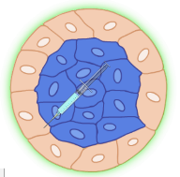

Introduction: In the investigation mode, you will make your own observations about mammalian embryo development.

Question: How does an embryo develop from a single cell to a multicellular organism?

- Observe: You are observing a single fertilized cell, right after a sperm and egg cell combined. Click Start to observe the cell undergoing morulation. Describe what you see.

- Observe: Click Continue to watch the embryo undergo blastulation.

- Describe what you see.

- Which developmental stage, from the COMPARE tab, does the embryo most resemble?

- Observe: Click Continue to watch the embryo undergo gastrulation. Describe what you see.

- Observe: Click Continue to watch the embryo undergo neurulation. Describe what you see.

If you click Continue again, you will see that this embryo will eventually grow into a gorilla.

(Activity B continued on next page)
Activity B (continued from previous page)

- Experiment: During development, cells undergo differentiation to become specialized cells such as muscle cells or nerve cells. You can investigate how this happens by dying certain cells and seeing what they become.

Click Start over, then Start to return to the end of morulation. Drag the syringe on the left to the embryo on the right and release to label cells with a colored dye. The cells on the outside can be labeled one color and the cells on the inside can be labeled another. Click Continue until “Gastrula” is highlighted on the flow chart.

Which cells become the gastrula?

The cells that disappear here will become part of the placenta, a fluid-filled organ that provides nutrients to the fetus, while the other cells will become part of the adult organism.

- Observe: Click Start over. Then click Start and Continue twice to reach the blastula stage. The cells inside the blastula have migrated to one side, creating a hollow center. Use the needle to label the cells on both the inside and the outside of the mass, against the hollow center. Click Continue three times to advance to the end.

Which cells become the body of the organism?

The blue cells that were up against the hollow center will become the primitive yolk sac, a fluid filled structure that provides nutrients to the embryo before the placenta forms.

- Observe: Click Start over. Then click Start and Continue to reach the gastrula stage. Notice there are three layers of cells inside the embryo. Use the needle to label those cells, then advance to the end.

- What does the top layer of cells (blue) become in the adult? (Note – the cell types will be color-coded in the adult.)

- What does the middle layer (red) become?

- What does the bottom layer (yellow) become?

- Each of the three cell layers became different parts of the adult organism. What does that mean about the cells that were once identical?

Activity C:  Details of development | Get the Gizmo ready:  - On the DIFFERENTIATION tab, select the Summary mode. | 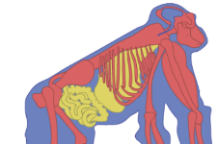

Introduction: Now that you’ve made some observations, you will go back and learn more about what is going on. In the summary mode, the steps in development will be explained.

Question: How do cells differentiate during early development?

- Observe: Click Start to watch morulation. Read the descriptions as you go.

- What is a morula?

- Click Continue again. Describe compaction.

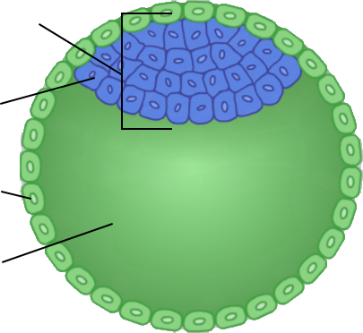

- Observe: Click Continue to watch blastulation. Label the diagram at left.

- What happens to the embryoblasts?

- What is the blastocoel?

- Click Continue. What cells form in the inner cell mass?

Embryonic stem cells, cells that have the ability to differentiate into all the cells in the organism, may be collected from the inner cell mass at this developmental stage.

- Click Continue. What forms inside the epiblasts, and what will this structure do for the fetus?

- Click Continue. What do the hypoblasts become and what will that structure do for the embryo?

Note: The trophoblasts will no longer be shown here, but they continue to provide support for the embryo and become part of the placenta later in development.

(Activity C continued on next page)
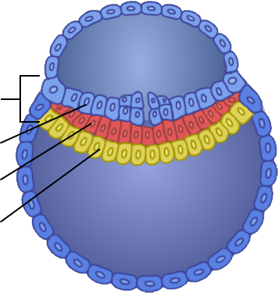
Activity C (continued from previous page)

- Observe: Click Continue to watch gastrulation.

- Describe what happens to the epiblast cells.

- Click Continue. What is the primitive streak?

- Click Continue, then label the diagram above. What happens to the epiblasts now?

- Observe: Click Continue to watch neurulation.

- Describe what happens to the trilaminar disk.

- Click Continue. Click the left, right, up and down arrows to observe different parts of the embryo. What do you notice about its shape?
- Switch to the COMPARE tab. Which developmental stage most resembles the neurula on the DIFFERENTIATION tab?
- Switch back to the DIFFERENTIATION tab and click Continue. What will the neural tube eventually form?

- Observe: Click Continue. Click on different parts of the gorilla diagram to learn what the endoderm, mesoderm and ectoderm cells become. Fill out the table below.

 | Ectoderm | Mesoderm | Endoderm
Structure

