Name: ______________________________________ Date: ________________________

Student Exploration: Prairie Ecosystem

Vocabulary: carnivore, consumer, ecosystem, equilibrium, extinct, food chain, herbivore, organism, population, prairie, producer

Prior Knowledge Questions (Do these BEFORE using the Gizmo.)

An ecosystem consists of all organisms (living things) in an area, plus the natural landscape.
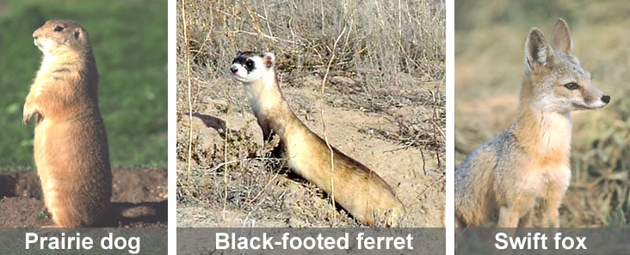
A prairie is flat or gently rolling grassland with few trees, such as in parts of central United States and Canada.

Organisms often found in a prairie ecosystem include prairie dogs, swift foxes, black-footed ferrets, and of course the grass itself.

- Which organism (grass, prairie dog, ferret, or fox) do you think is a producer (does not depend on other organisms for its food)? ___________________

- Organisms that depend on other organisms for food are consumers. Which consumer you think is a herbivore (eats plants only)? _____________________

- Which consumers are carnivores (eat meat)? ________________ and ________________

Gizmo Warm-up: Life on the Prairie
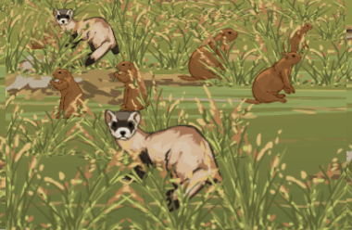
- The population of prairie dogs is all the prairie dogs living in the village. In the Gizmo, what are the starting numbers of

Grass: ______________ Prairie dogs: _____________

Ferrets: _____________ Foxes: __________________

- Click Advance year 10 times. On the DATA tab, look at the Bar graph and the Line graph. Do the populations change very much, or are they in equilibrium (stable)? Explain.

_________________________________________________________________________

Activity A:  Grass | Get the Gizmo ready:  - Click Reset.  - Be sure Show populations is selected. | 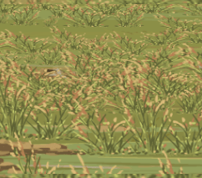

Question: How is grass important to a prairie ecosystem?

- Observe: Remove ALL animals from the prairie by clicking the minus (–) button next to each animal many times. Click Advance year 20 times. Does grass survive by itself? Explain.

_________________________________________________________________________

Because grass does not depend on other organisms for food, it is a producer. Grass gets what it needs from the Sun, air, and soil.

- Predict: Click Reset. Predict what will happen to the prairie dogs, ferrets and foxes if half of the grass were removed. Write “increase” or “decrease” in each blank below.

Prairie dogs: ______________ Ferrets: ______________ Foxes: ______________

- Experiment: Remove about half of the grass by clicking the minus – button. There should now be about 2,000 tons of grass. Click Advance year twice, and look at the Bar graph or the Line graph. What happened to each population—increase or decrease?

Prairie dogs: ______________ Ferrets: ______________ Foxes: ______________

- Think about it: What do you think will happen if you continue advancing years?

_________________________________________________________________________

- Experiment: Test your prediction by clicking Advance year until 20 years have passed.

    - What do you notice? __________________________________________________

    - Does the ecosystem return to equilibrium? _________________________________

    - How do you know? ___________________________________________________

- Extend your thinking: Suppose a fire swept through the prairie. The animals ran away, but about half the grass was burned. What would be the long-term results of this natural event?

_________________________________________________________________________

_________________________________________________________________________

Activity B:  Making a food chain | Get the Gizmo ready:  - Click Reset. | 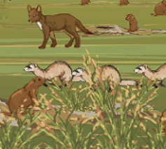

Question: How do animals affect the prairie ecosystem?

- Form hypotheses: What do you think each animal in the food chain eats? (Experiment with the Gizmo to help you make your hypotheses.)

Prairie dogs eat ____________. Ferrets eat _____________. Foxes eat ______________.

- Predict: Based on your hypotheses, predict how the changes below will affect the other animals. Write either “increase” or “decrease” next to each “P” (for “prediction”) in the table.

Change | Grass | Prairie dogs | Ferrets | Foxes
Add  prairie dogs | P:  ____________________________________________________________________________________________________________________________________________  A: |  | P:  ____________________________________________________________________________________________________________________________________________  A: | P:  ____________________________________________________________________________________________________________________________________________  A:
Add ferrets | P:  ____________________________________________________________________________________________________________________________________________  A: | P:  ____________________________________________________________________________________________________________________________________________  A: |  | P:  ____________________________________________________________________________________________________________________________________________  A:
Add foxes | P:  ____________________________________________________________________________________________________________________________________________  A: | P:  ____________________________________________________________________________________________________________________________________________  A: | P:  ____________________________________________________________________________________________________________________________________________  A:

- Test: Click Reset. Add as many prairie dogs as the Gizmo allows. Click Advance year once. Record the effects on the other three organisms in the table next to “A” (for “actual”). Then click Reset and do the same with ferrets, and then again with foxes.

- Analyze: In a food chain, each animal eats only one other animal or plant. Based on your experiments, what is the food that each animal eats? Explain how you know.

Prairie dogs eat ____________. Ferrets eat _____________. Foxes eat ______________.

Explain: __________________________________________________________________

_________________________________________________________________________

_________________________________________________________________________

- Apply: Now complete the Prairie Ecosystem food chain. Arrows point toward the animal that is eating. For example, “Mouse → Hawk” would mean that the mouse is eaten by the hawk.

________________ → ________________ → ________________ → ________________

Activity C:  Long term changes | Get the Gizmo ready:  - Click Reset. | 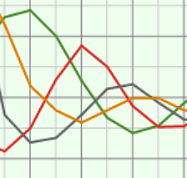

Introduction: Once common, the black-footed ferret is an endangered animal. In 1986 there were only 18 black-footed ferrets alive; today there are almost 1,000.

Question: What would happen to the ecosystem, long-term, with no black-footed ferrets?

- Form a hypothesis: Based on what you have seen so far, what do you think would happen if black-footed ferrets died out, or went extinct? Explain in detail.

_________________________________________________________________________

_________________________________________________________________________

_________________________________________________________________________

- Experiment: Click Reset, and remove all the ferrets from the prairie dog town. Click Advance year for 12 years. What happens?

_________________________________________________________________________

_________________________________________________________________________

- Analyze: Why did removing ferrets have such a powerful effect on the prairie ecosystem?

_________________________________________________________________________

_________________________________________________________________________

- On your own: Investigate other major changes to the prairie ecosystem. Run each experiment for 20 years to see what the long-term results would be.

  - Give an example of a change that the ecosystem was able to recover from and return to equilibrium. __________________________________________________
___________________________________________________________________

  - Give an example of a change that the ecosystem was not able to recover from. Can you explain why? ____________________________________________________
___________________________________________________________________

