Physics Name _________________________________ Date ________ Period _______

1 – Wave Exploration (page 1)

Introduction - Please use the links and open each of the 5 wave videos in You Tube. Next to each picture, please make two observations about the wave in the video. What is something interesting you observe about the motion? What is something surprising or unexpected? Once you have made the two observations, please write one question about each video. Think about what might be causing the observations you made. Please use complete sentences when you are writing your observations or questions.

1. Slinky with bottle https://youtu.be/_wTvnsfqMIc
Observations:

1)

2)

Question:

2. Tuning Fork in Water with Slo Mo Guys https://youtu.be/VCERs0v1OoI

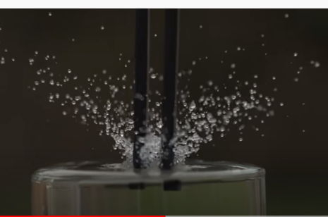
Observations:

1)

2)

Question:

3. String Ray https://youtu.be/I6AIL09Bonc

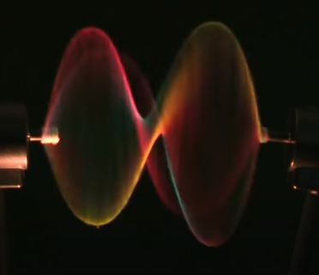
Observations:

1)

2)

Question:

1 – Wave Exploration (page 2)

4. 90 ft. Vertical Spike in Slo Mo https://youtu.be/iWKFPTgkpXo
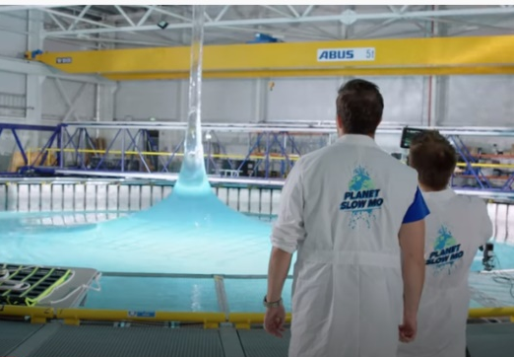
Observations:

1)

2)

Question:

5. Dominoes in Slow Motion https://youtu.be/g0gvRLi8EQo

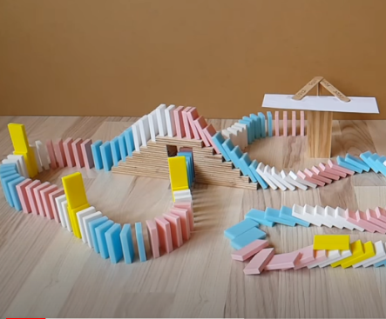
Observations:

1)

2)

Question:

6. Finally, write a short reflection about your favorite wave video. Please use 4 or 5 complete sentences. What surprised you about this video? What did the wave in the video remind you of? Where might we see another example of this wave? Do you think that there might be more that one type of wave exhibited in the video? What other questions do you have about the wave depicted?
Reflection:

